Font Definitions

First definition is used as default. In this case, the default is Courier New 7pt.

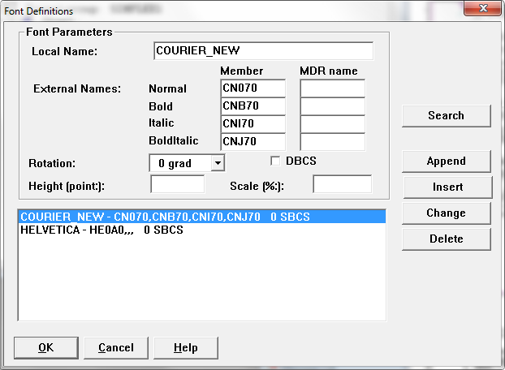

The default font will be used if no font is specified in the ‘TEXT’ dialog.

Normal Courier New Font Bold Courier New Font

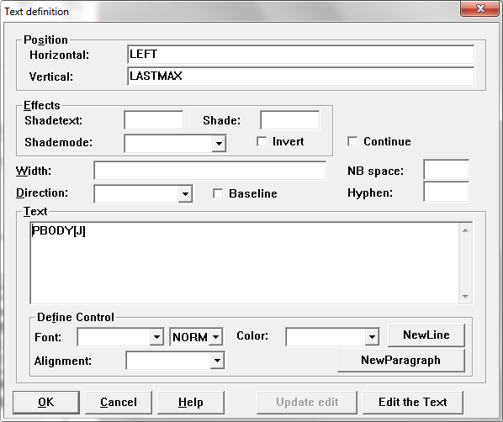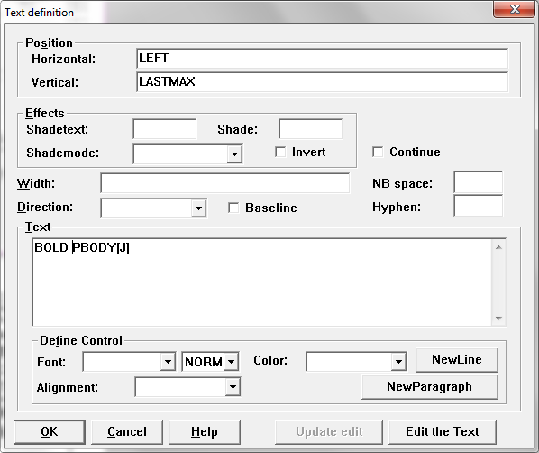

This is the same as using FONT CN070 FONT CNB70

NORMAL, BOLD, ITALIC, BOLDITALIC are keywords for selecting the style of the Font Definition.

Note: This only works if that style definition is defined. In the example above, Courier_New has all the styles available. The Helvetica font will not be bold even if we put a ‘BOLD’ tag.

To use a font that has been defined.

1. Select from the Drop down menu the font definition name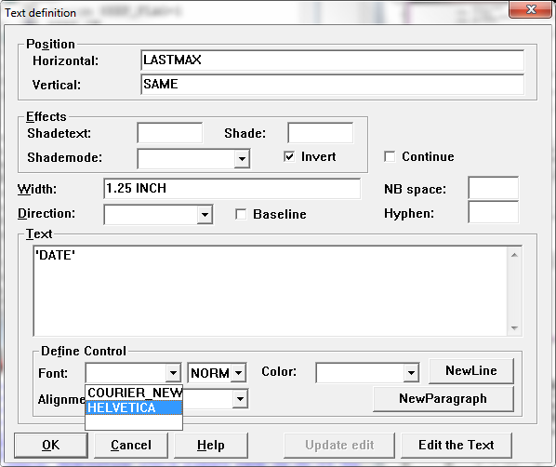
2. This will place ‘FONT {FONT_DEF_NAME}’ in the text box.

You can also just manually input this information.

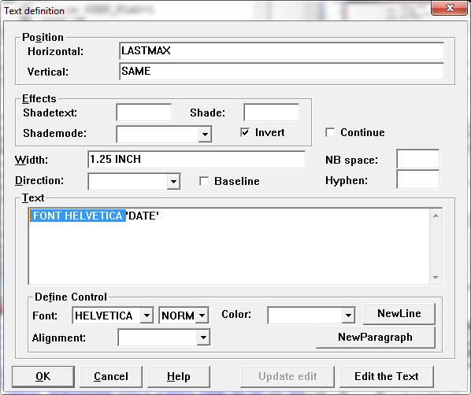

If you use a FONT {FONT_DEF_NAME} that is not defined you will get an error.

(This does not apply if you use the actual font code ‘FONT CNB70’, ‘FONT HE0A0’, etc.)

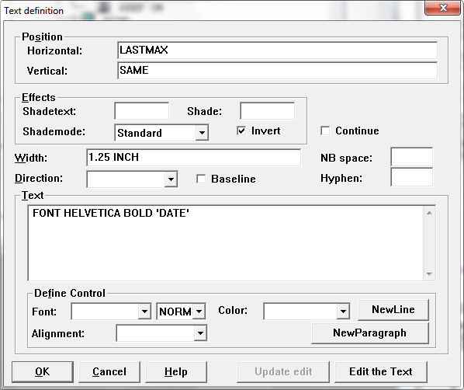

This case ‘HELVETICA’ is defined, the style ‘BOLD’ isn’t. Papyrus will fall back to normal if possible.

C:\Users\MHolden\Pictures\Untitled.png

‘ARIAL_8’ is not defined at all. There is an error trying to find the font in the library. Nothing is output.

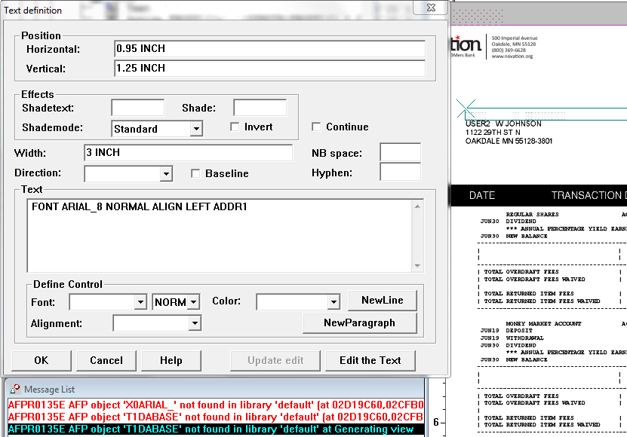

You can still use the actual font code if it exists in the library.

